UNIT 1.4: Interviews

🧩 Brainstorming Activity: Interviews

* Have you already experienced a job interview?
* What are some common interview questions asked by employers during job interviews?
* It's acceptable for an interviewee to bring up salary and benefits during the first interview.
* What are some strategies to handle difficult interview questions?
* It's ethical for an interviewer to ask a candidate about their age, religion, or political beliefs during an interview.
* How can candidates showcase their strengths and relevant experiences during an interview?
* Non-verbal communication (body language, eye contact, etc.) can be just as important as verbal communication in an interview.
* Using humour in a job interview can be an effective way to build rapport with the interviewer.
* It's okay to ask the interviewer about their personal background and interests during an interview to build a personal connection.
* How can candidates effectively address any employment gaps or career changes during an interview?
* It's better to be slightly overqualified for a job than underqualified, even if it means being overqualified for the position.
* What should you do...
* Soft skills are highly valued by employers as they contribute to a positive work environment and overall job performance. Among the following soft skills, which one it the most important, according to you?

🧩 Vocabulary: Phrasal verbs words frequently used during interviews

**BRING IN - TAKE ON - GO OVER - ELABORATE ON - CARRY OUT - IMPLEMENT**

**Interviewer**: "Could you please ________________ your experience with software development and ________________ any specific projects you've worked on?"

**Candidate**: "Of course! In my previous role, I ________________ the lead developer position for a web application project where I ________________ new features and ________________ thorough testing to ensure its quality."

**Interviewer**: "That sounds impressive. Can you ________________ the technologies you've worked with, such as programming languages or frameworks?"

**RESULT IN - EXPERIENCE WITH - UTILIZE - FOSTER - WORK ON –   
BRING ABOUT - STREAMLINE – INITIATE**

**Candidate**: “Certainly. I have ________________ various programming languages, including Java, Python, and JavaScript. Moreover, I ________________ popular frameworks like React and Spring to ________________ the development process.”

**Interviewer**: “Great! Tell me about a situation where you had to ________________ a successful collaboration between the development and testing teams.”

**Candidate**: “In my previous project, I ________________ regular meetings to ________________ communication between the teams and ________________ resolving any conflicts. This ________________ improved cooperation and a significant reduction in bugs.”

**WORDS TO USE IN THE PARAGRAPHS ABOVE: KEEP UP WITH – HANDLE - SEEK OUT – ATTEND – WORK ON – DIVE INTO – STAY UPDATED ON – COLLABORATE WITH – FIGURE OUT – SET UP – RUN INTO – NETWORK WITH**

**Interviewer**: “Impressive problem-solving skills. How do you ________________

the latest trends in the software industry?”

**Candidate**: “I am constantly ________________ online resources and ________________ technical articles to ________________ emerging technologies. I also ________________ tech conferences to ________________ industry experts.”

Interviewer: “Excellent! Can you provide an example of a complex project you’ve ________________ and how you ________________ the challenges that arose?”

**Candidate**: “Certainly. I once ________________ a team to develop a mobile app that required integrating multiple APIs. When we ________________ integration issues, I ________________ external consultants to ________________ the solutions.”

**ENSURE – BRING TOGETHER - RELY ON – CALL UPON – DELIVER – KEEP THE PROJECT ON TRACK – DEAL WITH – THRIVE ON - DELEGATE – FOLLOW UP – STEP IN – PRIORITIZE – MEET**

**Interviewer**: "It seems you have a strong ability to ________________ diverse talents. How do you ________________ the team's productivity?"

**Candidate**: "I make sure to ________________ tasks based on individual strengths, ________________ on progress regularly, and ________________ when additional support is needed to ________________ ."

**Interviewer**: "Thank you for sharing your experiences. Lastly, how do you ________________ tight deadlines and pressure in software development?"

**Candidate**: "I ________________ challenges and ________________ tasks to ________________ the deadlines. Additionally, I ________________ my team's expertise and ________________ external resources if necessary to ________________ high-quality results on time."

❤️ Theory: Interviews

✔️Do's:

* Research the Company: Learn about the company's mission, values, culture, and products/services. Understand their industry and competitors.
* Review the Job Description: Understand the job requirements and responsibilities so you can tailor your responses to demonstrate your suitability.
* Practice Common Interview Questions: Prepare answers for typical interview questions, such as your strengths and weaknesses, your achievements, and your ability to handle challenges.
* Prepare Questions to Ask: Prepare thoughtful questions to ask the interviewer about the company, team, or role. It demonstrates your interest and engagement.
* Dress Professionally: Wear appropriate attire that aligns with the company culture and the industry. When in doubt, it's better to be slightly overdressed than underdressed.
* Arrive Early: Aim to arrive at the interview location 10-15 minutes early. Punctuality is important.
* Bring Multiple Copies of Your Resume: Have extra copies of your resume in case the interviewer or panel needs them.
* Use the STAR Method: When answering behavioural questions, use the STAR method (Situation, Task, Action, Result) to structure your responses.
* Show Enthusiasm: Express your enthusiasm for the role and the company. Let your passion for the job shine through.
* Listen Actively: Pay close attention to the interviewer's questions and statements. This will help you provide relevant responses and build rapport.

❌Don'ts:

* Don't Arrive Late: Punctuality is crucial. Being late for an interview is generally seen as disrespectful and unprofessional.
* Don't Overlook Your Appearance: Dressing inappropriately or neglecting personal grooming can create a negative impression.
* Don't Speak Negatively: Avoid speaking negatively about past employers, colleagues, or experiences. Focus on the positive aspects.
* Don't Interrupt: Allow the interviewer to finish their questions before responding. Interrupting is impolite and can disrupt the flow of the interview.
* Don't Exaggerate or Lie: Be honest about your qualifications and experiences. Exaggerating or lying can lead to credibility issues.
* Don't Be Unprepared: Lack of preparation can make you appear disinterested or unqualified for the role.
* Don't Forget to Follow Up: Send a thank-you email or note after the interview to express your appreciation for the opportunity and reiterate your interest in the position.

Preparation Steps:

* Research the Company: Learn about the company's history, products or services, culture, recent news, and competitors.
* Understand the Job: Carefully review the job description, noting key responsibilities and requirements.
* Practice Your Answers: Prepare answers to common interview questions and use the STAR method for behavioural questions.
* Prepare Questions: Develop insightful questions to ask the interviewer about the role, team, and company.
* Plan Your Route: Know the interview location, and plan your route ahead of time. Consider traffic and transportation options.
* Gather Materials: Bring multiple copies of your resume, a notepad, and a pen. Also, consider any other materials or documents requested by the employer.
* Dress Appropriately: Choose professional attire that aligns with the company's dress code.
* Practice Interview Etiquette: Practice good manners, politeness, and professional behaviour during mock interviews.
* Mock Interviews: Consider conducting mock interviews with a friend or career advisor to gain confidence and receive feedback.
* Relax and Stay Positive: On the day of the interview, take deep breaths, stay positive, and remember that the interview is an opportunity for both you and the employer to determine if you're a good fit.

❤️ Theory: The S.T.A.R method

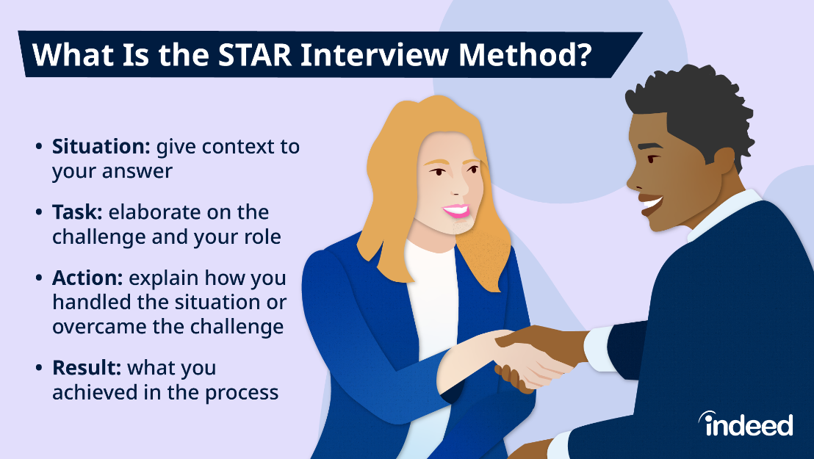

Behavioural Question: ***"Can you give me an example of a time when you had to resolve a conflict within your team?"***

**➡️ Situation (S):**

Several months ago, while working as a project manager for XYZ Company, I encountered a conflict within my project team. We were tasked with delivering a critical project, and two team members, John and Sarah, had differing opinions on the project's approach.

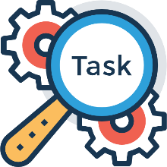**➡️ Task (T):**

My task was to resolve the conflict, ensure the project stayed on track, and maintain a positive working relationship among the team members.

➡️ **Action (A):** To address the conflict, I took the following actions:

* Individual Discussions: I met separately with John and Sarah to understand their perspectives and concerns. This allowed them to express their viewpoints without feeling defensive in front of the entire team.
* Identify Common Goals: During these discussions, I focused on finding common ground between their ideas and aligning them with the project's goals. It became clear that both wanted project success but had different approaches.
* Facilitate a Team Meeting: After individual discussions, I organized a team meeting with John and Sarah to foster open communication. I encouraged them to share their revised ideas, considering each other's feedback.
* Mediate and Find a Compromise: During the meeting, I acted as a mediator, helping them find common elements in their proposals. We eventually reached a compromise that incorporated the strengths of both approaches.
* Document Agreements: I ensured that we documented the agreed-upon project plan and roles, which eliminated future misunderstandings.

**➡️ Result (R):**

The result of my actions was a harmonious team that successfully completed the project ahead of schedule and under budget. The conflict resolution process also improved communication and collaboration within the team for future projects. John and Sarah continued to work effectively together, and their willingness to compromise led to more innovative solutions in the long run.

**The STAR method provides a structured and detailed response to the behavioural question, showcasing the candidate's ability to resolve conflicts, mediate discussions, and achieve positive outcomes. Remember to emphasize the positive result or impact of your actions when using the STAR method in your interview responses.**